Configuration Management with Ansible and Terraform

Ansible is an open-source automation tool that simplifies IT tasks like configuration management, application deployment, and orchestration by using human-readable YAML files called playbooks.

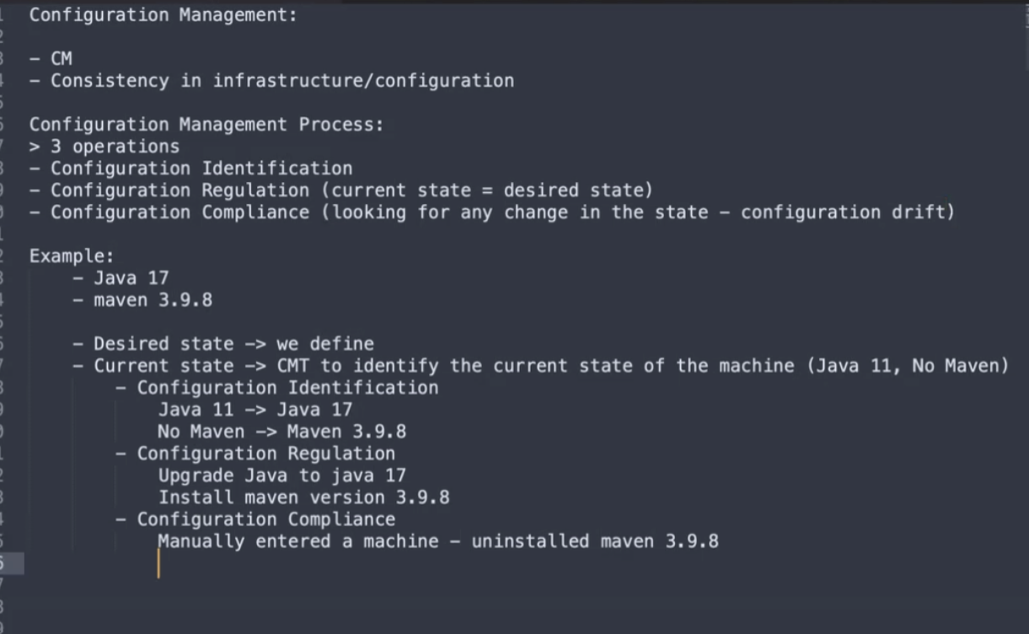

Terraform is more a provisioning tool even if it can handle some aspects of configuration management (by provisioning and managing infrastructure resources).

Infrastructure as Code (IaC) is the practice of managing and provisioning computing infrastructure through machine-readable configuration files, rather than through physical hardware configuration or interactive configuration tools.

How to SSH to a machine: ssh username@ip_hostname

Default port for SSH: 22

How to SSH to a particular machine: ssh username@ip_hostname -p 42006

SSH

Into the same machine:

$ ssh localhost

$ ssh localhost -p 42006

# exit

Ansible: Passwordless SSH

Create a SSH keypair

[A]$ ssh-keygen

- Press Enter

- Overwrite? Press y

- Passphrase: Press Enter

- Confirm Passphrase: Press Enter

Copy the public key from Machine A

[A]$ cat ~/.ssh/id_rsa.pub

Paste the public key to ~/.ssh/authorized_keys on Machine B

[A & B - are the same machine]

[B]$ nano ~/.ssh/authorized_keys

Paste the public key you have copied from Machine A

$ ssh localhost -p 42006

# exit

Ansible Verification:

$ ansible  --version

Ansible Inventory file:

$ sudo nano /etc/ansible/hosts

[myservers]

localhost

$ ansible -m ping localhost

Ansible Inventory file:

$ sudo nano /etc/ansible/hosts

[myservers]

localhost:42006

$ ansible -m ping localhost

$ ansible -m ping myservers

$ ansible all --list-hosts

$ ansible-inventory --graph

<https://docs.ansible.com/ansible/2.9/modules/list_of_all_modules.html>

Module help documentation:

$ ansible-doc

$ ansible-doc ping

Shell Module:

$ ansible all -m shell -a "hostname"

 ansible all -m shell -a "pwd"

$ ansible all -a "hostname"

$ ansible all -a "pwd"

Gather facts:

$ ansible all -m setup

$ ansible all -m setup -a 'filter=ansible_hostname'

$ ansible all -m setup -a 'filter=ansible_user_*'

$ ansible all -a uptime

$ ansible all -a "free -m"

$ ansible all -m apt -a "name=tree state=absent"

[Privilege escalation]

$ ansible all -m apt -a "name=tree state=absent" --become

[IF tree not installed]

$ ansible all -m apt -a "name=tree state=present"

[Privilege escalation]

$ ansible all -m apt -a "name=tree state=present" --become

$ ansible all -m file -a 'dest=/root/sample.txt state=touch mode=600 owner=root group=root' --become

$ ansible all -a "ls /root/sample.txt" --become

$ ansible all -m copy -a 'content="MY demo content" dest=/root/my_demo.txt' --become

$ ansible all -a "cat /root/my_demo.txt" --become

8/24/2024

Inventory file:

$ cat /etc/ansible/hosts

[myservers]

localhost:42006

Ansible Modules:

$ ansible all -m debug -a "msg=HelloWorld!"

Create, Validate & Parse YAML - using Python

$ nano yaml_demo.py

import yaml

# Create a YAML structure & file

def create_yaml():

data = {

'name': 'Abhi',

'age': '20',

'city': 'Mumbai'

}

with open('data.yaml', 'w') as file:

yaml.dump(data, file)

# Validate the YAML file

def validate_yaml():

try:

with open('data.yaml', 'r') as file:

data = yaml.safe_load(file)

print("Valid YAML file.")

return data

except yaml.YAMLError as exc:

print("YAML file error: ", exc)

return None

# Parse the YAML file

def parse_yaml(data):

if data:

print("Name: ", data['name'])

print("Age: ", data['age'])

print("Location: ", data['city'])

if __name__ == "__main__":

create_yaml()

my_data = validate_yaml()

parse_yaml(my_data)

Run the python file:

$ sudo python yaml_demo.py

Configuring Apache Webserver using Ansible:

Check the status of apache webserver:

$ ansible all -m shell -a "service apache2 status"

$ nano apache2.yaml

---

- hosts: all

  become: true

  tasks:

    - name: Install apache2

      apt: name=apache2 update_cache=yes state=latest

    - name: Enable mod_rewrite

      apache2_module: name=rewrite state=present

      notify:

        - restart apache2

  handlers:

    - name: restart apache2

      service: name=apache2 state=restarted

Execute the playbook:

$ ansible-playbook apache2.yaml

Check the status of apache webserver:

$ ansible all -m shell -a "service apache2 status"

Anchors & Aliases in YAML:

$ nano users.yml

---

users:

  - &default_address

    address:

      street: "ABC Main St"

      city: "Sometown"

      state: "CA"

      zip: "12345"

  - name: "Alice"

    <<: *default_address

  - name: "Bob"

    <<: *default_address

  - name: "Charlie"

    <<: *default_address

$ nano print_users.yml

---

- name: Print the users with default address

  hosts: all

  gather_facts: no

  vars_files:

    - users.yml

  tasks:

    - name: Print user details

      debug:

        msg: "User: {{ item.name }} lives at {{ item.address.street }}, {{ item.address.city }}, {{ item.address.state }}, {{ item.address.zip }}"

      loop: "{{ users }}"

      when: item.name is defined

$ ansible-playbook print_users.yml --syntax-check

$ ansible-playbook print_users.yml

Global Variable in Ansible:

$ mkdir ansible_demo_01

$ cd ansible_demo_01

$ mkdir group_vars

$ nano group_vars/all.yml

---

greeting: "Hello, World!"

custom_number: 56

$ nano demo_playbook.yml

---

- name: Demo playbook for group vars testing

  hosts: all

  gather_facts: no

  tasks:

    - name: Print the greeting message

      debug:

        msg: "{{ greeting }}"

    - name: Print the custom number

      debug:

        msg: "{{ custom_number }}"

$ ansible-playbook demo_playbook.yml

YAML for Data serialization using Python:

$ cd

$ nano serialize.py

import yaml

#Create a Python dictionary

data={

'title': 'YAML serialization example',

'version': 1.0,

'items': ['item1', 'item2', 'item3']

}

#Serialize the dictionary to a YAML file

with open('serial_output.yaml', 'w') as file:

yaml.dump(data, file, default_flow_style=False)

print("Data serialization complete - serial_output.yaml")

$ python serialize.py

Install NodeJS using Ansible Playbook execution:

$ nano node.yaml

---

- name: Install nodejs

  hosts: all

  gather_facts: yes

  become: true

  tasks:

    - name: Add apt key for node installation source

      apt_key: url=https://deb.nodesource.com/gpgkey/nodesource.gpg.key

    - name: Add the node repo

      apt_repository:

        repo: 'deb https://deb.nodesource.com/node_0.10 {{ ansible_distribution_release }} main'

        update_cache: no

    - name: install nodejs

      apt: name=nodejs

$ ansible-playbook node.yaml

$ ansible all -m shell -a "node --version"

$ ansible-playbook node.yaml --verbose

$ ansible-playbook node.yaml --check

$ ansible-playbook node.yaml --syntax-check

Variables in Ansible:

$ nano basic.yaml

---

- hosts: all

  vars:

    salutations: Hello everyone!!!

  tasks:

    - name: Using Ansible variable

      debug:

        msg: "{{ salutations }}"

$ ansible-playbook basic.yaml

Loops:

$ nano loops.yaml

---

- name: My loop example

  hosts: all

  vars:

    my_list_var:

      - my_list_01

      - my_list_02

    my_dict_var:

      name: "Abhi"

      type: "demo"

  tasks:

    - name: loop with direct list value

      debug:

        msg: "{{ item }}"

      loop:

        - one

        - two

    - name: loop with list var

      debug:

        msg: "{{ item }}"

      loop: "{{ my_list_var }}"

    - name: with_items for list var

      debug:

        msg: "{{ item }}"

      with_items: "{{ my_list_var }}"

    - name: with_dict for dict var

      debug:

        msg: "New key: {{ item.key }}, New value: {{ item.value }} "

      with_dict: "{{ my_dict_var }}"

    - name: with_items for list var

      debug:

        msg: "{{ item.0 }} - {{ item.1 }}"

      with_indexed_items:

        - one

        - two

$ ansible-playbook loops.yaml

Does that mean that I successfully created the inventory file web_app to define the remote server?